 |  |  |  |  |  | MOTORKHANA  ENTRY FORM |  |  |  |  |  |  |  |  |  |  |  | OFFICIAL USE ONLY
 |  |  |  |  |  |  |  |  |  |  |  |  |  |  |  |  |  | CLASS |  |  |  |  | CAR NO(s)
 |  |  |  |  |  |  |  |  |  |  |  |  |  |  |  |  |  |  |  |  |  |  | Driver 1 |  |  | Driver 2 | Driver 3
Held under the ISC of the FIA and the National Competition Rules of Motorsport Australia.
EVENT | NSW Motorkhana C/ship Rnd 6 & Ernie’s Revenge Motorkhana |  |  |  |  |  |  |  |  |  |  |  |  | PERMIT NO. |  |  |  |  | 226/1406/05
CLUB | Thornleigh Car Club |  |  |  |  |  |  |  |  |  |  |  |  | DATE |  |  |  |  | Sunday, 14th June 2026
VENUE | Nirimba Education Precinct, Eastern Rd, Nirimba Fields NSW |  |  |  |  |  |  |  |  |  |  |  |  | ENTRY FEE |  |  |  |  | State $90, M/Club $70, All Jnrs $40
COMPETITOR (CAR OWNER) DETAILS
Name |  |  |  |  |  |  |  |  |  |  |  |  |  |  | Club
Address |  |  |  |  |  |  |  |  |  |  |  |  |  |  | Club #
Suburb |  |  |  |  |  |  |  |  |  |  |  |  |  |  | Motorsport
State |  |  |  |  |  |  | Postcode |  |  |  |  |  |  |  | Australia Lic. #
Email |  |  |  |  |  |  |  |  |  |  |  |  |  |  | Phone
DRIVER 1 DETAILS |  |  |  |  |  |  |  |  | I am competing in the: State / Multi-club section of this event.
Name |  |  |  |  |  |  |  |  |  |  |  |  |  |  |  | Club
Address |  |  |  |  |  |  |  |  |  |  |  |  |  |  |  | Club #
Suburb |  |  |  |  |  |  |  |  |  |  |  |  |  |  |  | Motorsport Australia Lic. #
State |  |  |  |  |  |  | Postcode |  |  |  |  |  |  |  |  | Category |  |  |  |  |  | Junior / Lady
Email |  |  |  |  |  |  |  |  |  |  |  |  |  |  |  | Phone
EMERGENCY CONTACT DETAILS
Name |  |  |  |  |  |  |  |  |  |  | Phone |  |  |  |  |  |  |  |  | Attending Event? Y / N
DRIVER 2 DETAILS |  |  |  |  |  |  |  |  | I am competing in the: State / Multi-club section of this event.
Name |  |  |  |  |  |  |  |  |  |  |  |  |  |  |  | Club
Address |  |  |  |  |  |  |  |  |  |  |  |  |  |  |  | Club #
Suburb |  |  |  |  |  |  |  |  |  |  |  |  |  |  |  | Motorsport Australia Lic. #
State |  |  |  |  |  |  | Postcode |  |  |  |  |  |  |  |  | Category |  |  |  |  |  | Junior / Lady
Email |  |  |  |  |  |  |  |  |  |  |  |  |  |  |  | Phone
EMERGENCY CONTACT DETAILS
Name |  |  |  |  |  |  |  |  |  |  | Phone |  |  |  |  |  |  |  |  | Attending Event? Y / N
DRIVER 3 DETAILS |  |  |  |  |  |  |  |  | I am competing in the: State / Multi-club section of this event.
Name |  |  |  |  |  |  |  |  |  |  |  |  |  |  |  | Club
Address |  |  |  |  |  |  |  |  |  |  |  |  |  |  |  | Club #
Suburb |  |  |  |  |  |  |  |  |  |  |  |  |  |  |  | Motorsport Australia Lic. #
State |  |  |  |  |  |  | Postcode |  |  |  |  |  |  |  |  | Category |  |  |  |  |  | Junior / Lady
Email |  |  |  |  |  |  |  |  |  |  |  |  |  |  |  | Phone
EMERGENCY CONTACT DETAILS
Name |  |  |  |  |  |  |  |  |  |  | Phone |  |  |  |  |  |  |  |  | Attending Event? Y / N
DESCRIPTION OF CAR AND CLASS DETAILS
Make |  |  |  |  |  |  |  | Model |  |  |  |  |  |  |  |  | Year
Body Type |  |  |  |  |  |  |  | Colour |  |  |  |  |  |  |  |  | Wheelbase
Vehicle Class |  |  |  |  | ⃝ A (Wheelbase up to 2150 mm) |  |  |  |  |  |  |  | ⃝ E (4WD Vehicles)
 |  |  |  |  | ⃝ B (Wheelbase 2151 – 2390 mm) |  |  |  |  |  |  |  | ⃝ F (Specials – Front Wheel Drive)
 |  |  |  |  | ⃝ C (Wheelbase 2391 - 2574 mm) |  |  |  |  |  |  |  | ⃝ G (Specials – Rear Wheel Drive)
 |  |  |  |  | ⃝ D (Wheelbase 2575 mm & over) |  |  |  |  |  |  |  | ⃝ H (Production Vehicle Based Specials)

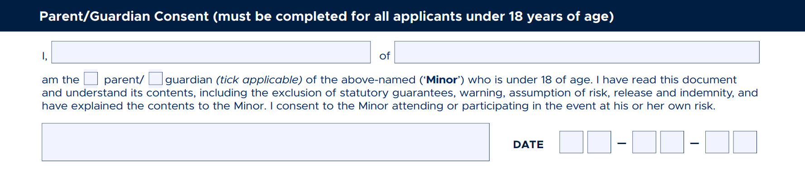
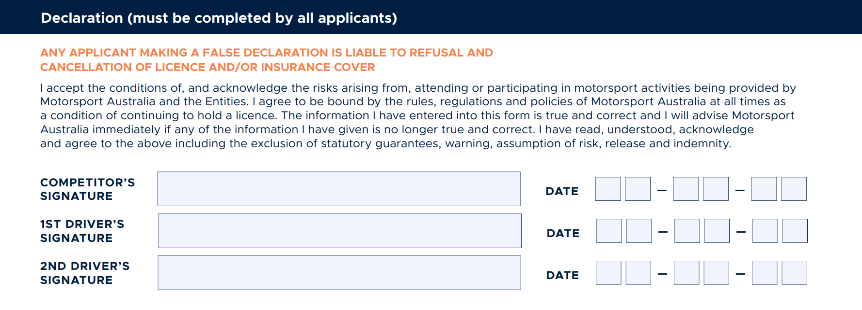
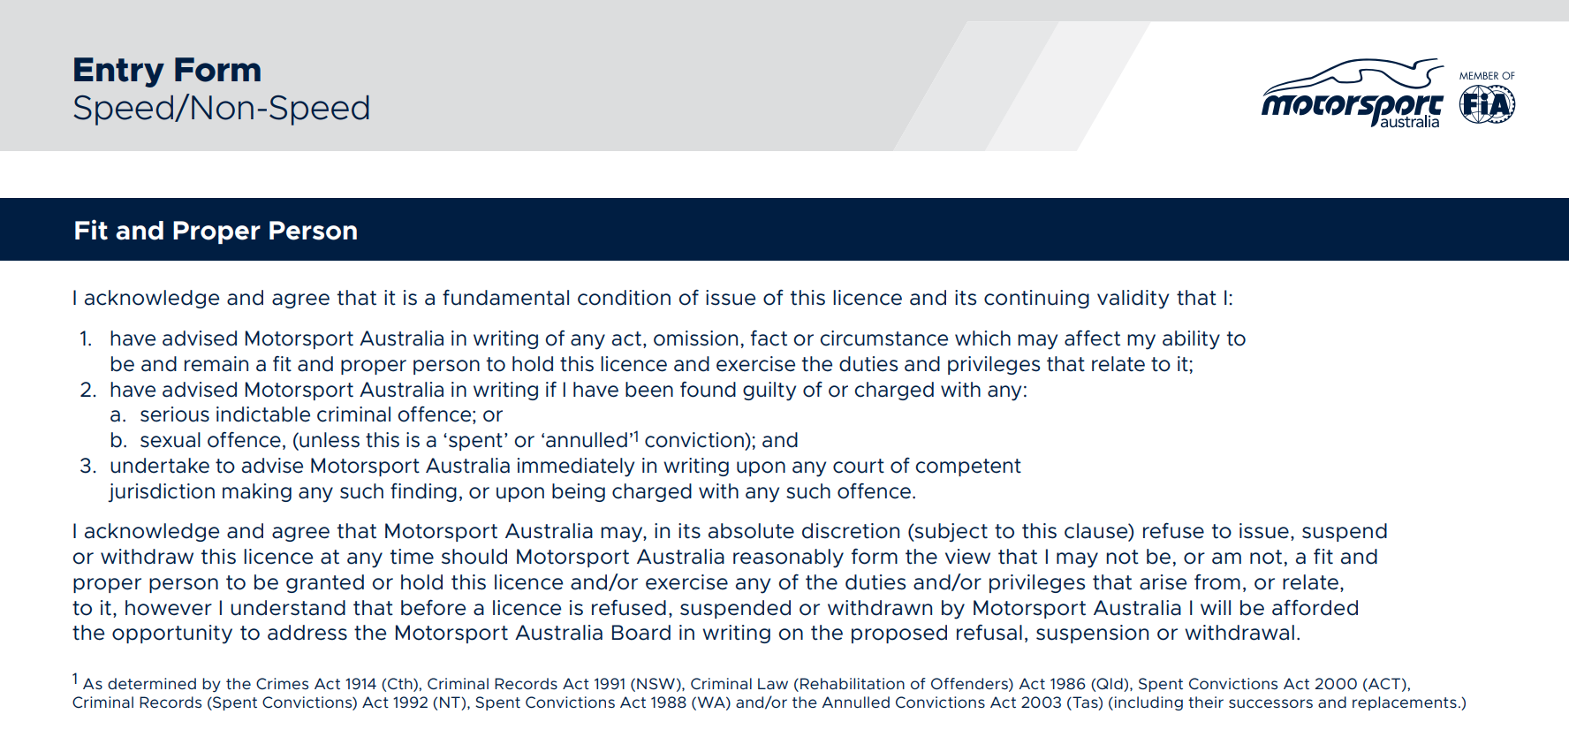
3RD

